## ANALYSING HOUSING PRICES IN METROPOLITAN AREAS OF INDIA

1. INTRODUCTION
   1. OVERVIEW

As per the report , housing prices were increasing according to their location, maintenance, facilities and bed room.

Bangalore has increased 10% prices comparing to others.The prices of residential properties in Chennai went up 6 percent to Rs.7653 per square feet .

* 1. PURPOSE

As there are more people living in this areas,the demand for housing and commercial properties is higher than others.

This leads to higher property prices and better rental income.People who are looking for a great return on investment.

1. PROBLEM DEFINITION & DESIGN THINKING
   1. EMPATHY MAP



* 1. IDEATION & BRAINSTORM MAP

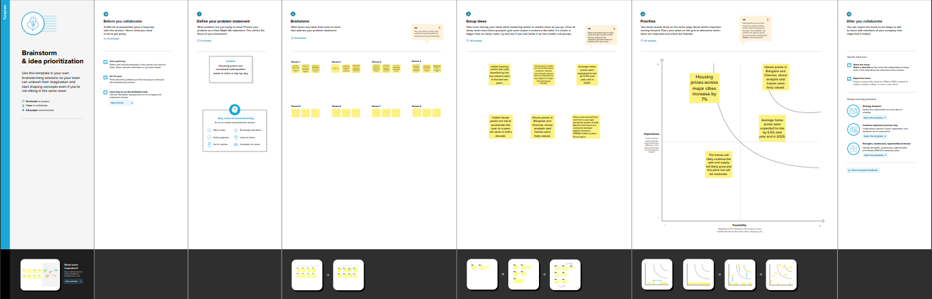

1. RESULT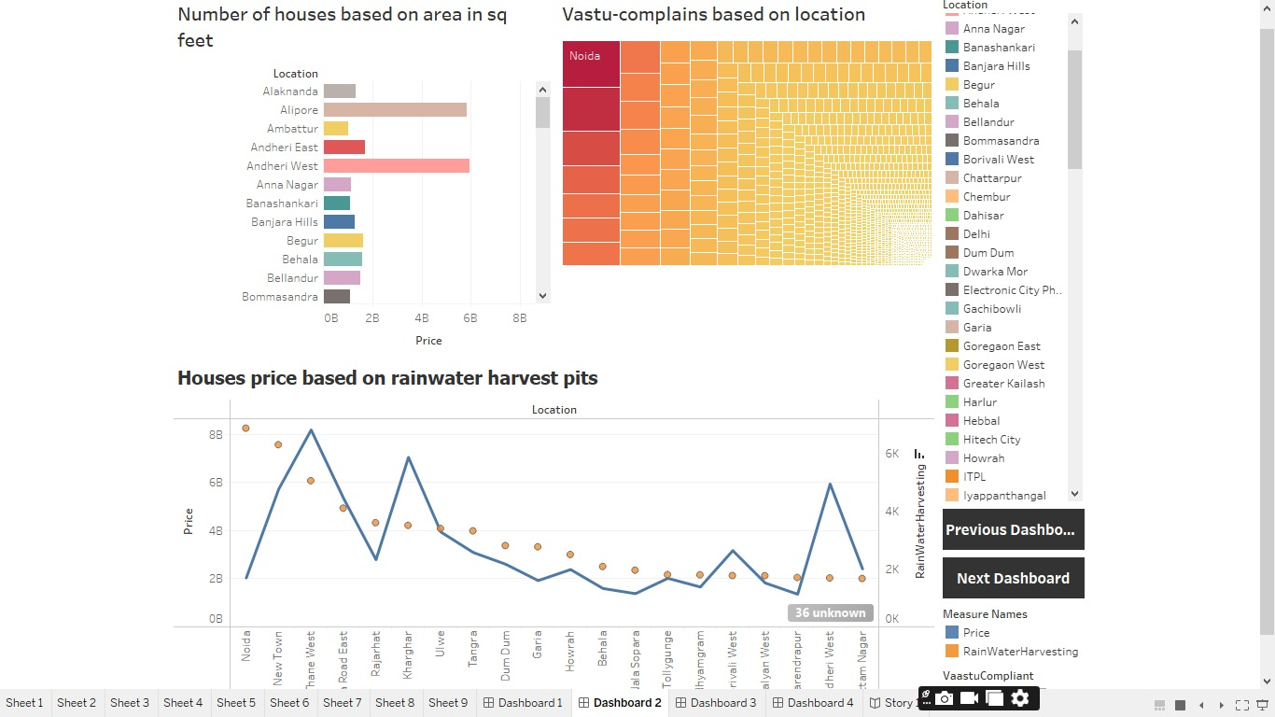

4 ADVANTAGES & DISADVANTAGES

ADVANTAGES

*A greater level of job opportunities

*Better education system

*Safer for children

*Less crime

*More affordable living

DISADVANTAGES

*High polution and traffic

*Lack of social control

*Limited privacy

*Excess network trust

*Less communication between relationship

5 APPLICATIONS

* Housing price prediction can help the developer determine the selling price of a house and can help the customer to arrange the right time to purchase a house.

There are three factors that influence the price of a house:

* Physical condition

*Concept

*Location

*Property prices in India are expected to increase 7.5% on a pan-India basis this year average house prices were forecast to rise 6% next year in 2024.

6 CONCLUSION

*In future houses in metropolitan areas plays a major role in our day-to-day life.Indian real estate market holds significant potential challenge such as regulatory complexities funding constraints and market fluctuation must also be navigated , staying informed about market trends, focusing on customer needs and adopting innovative solution and strategies will be key to thriving in this dynamic sector.

7 FUTURE SCOPE

*Projected growth by 2030 for the sector is USD 1trillian .By 2025 , the real estate sector is expected to contribute 13% of the country today GDP.

*The Indian real- estate market has traditionally been a significant contribution to the country's GDP and employment generation.It encompasses various segment ,including residential.

" IMPORTANT SESSION FOR FUTURE SCOPE"

~ Urbanisation and population

~ Affordable housing

~ Infrastructure development

~ Commercial and Retail

~ Foreign director and investment

~Co-living and Co-working spaces

~Tecnology integration